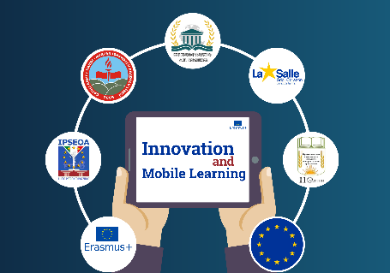

Innovation and Mobile Learning

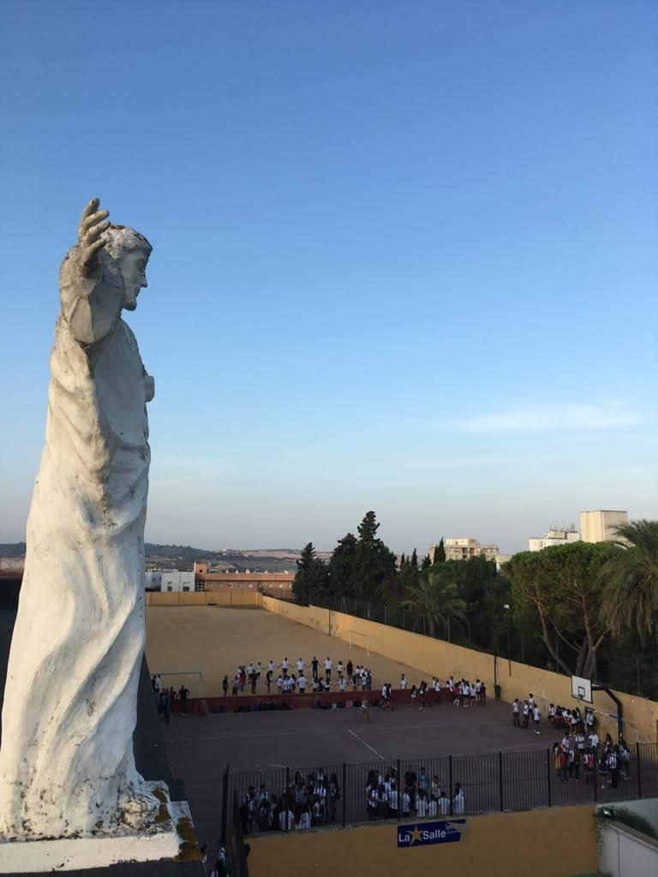
DAY 1 MONDAY, FEBRUARY 11th 2019

09.15 | Meeting at the school.
09.15-11.15 | Welcome speeches  Video presentation of the city of Jerez  Students presentation of typical dress and dance.
11.15-11.45 | Coffee break
11.45- 12.45 | Cultural activity: flamenco music and dance by professional dancer.
12.45-13.45 | School tour  Methodological exchange
13.45-14.45 | Break time
14:45-16:00 | Lunch at school: Paella
16.00-16.30 | Preparation of the afternoon activity
16.30-19.30 | Treasure hunt in mixed groups around Jerez
19.30-21.00 | Free time
21.00 | Dinner
DAY 2 TUESDAY, FEBRUARY 12th 2019

08.15 | Meeting at the school
08.15-9.15 | Google Drive workshop Part I
09.15-10:15 | Google Drive workshop Part II
10:15-11:00 | Coffee break in the city centre
11.00-12.15 | Reception at the Town Hall
12.30- 14.00 | Visit to the Moorish Alcázar of Jerez
14.30-16:00 | Lunch in the city centre
17.00-19.00 | Visit to the famous winery González Byass
19:00-21:00 | Free time
21.00 | Dinner

DAY 3 WEDNESDAY, FEBRUARY 13th 2019

09.15 | Meeting at the school
09.15-11.15 | Google Forms workshop
11.15- 11.45 | Coffee break
12:00-19.00 | Day trip to the city of Cádiz  Picnic lunch in Cádiz
19.00-21.00 | Free time
21.00 | Dinner

DAY 4 THURSDAY, FEBRUARY 14th 2019

09.15 | Meeting at the school
09.15- 11.15 | Google Maps workshop
11.15-11.45 | Coffee break
12:00-19.00 | Day trip in Seville, the capital city of Andalusia  Picnic lunch in Seville
19.00-21.00 | Break time
21.00 | Farewell dinner

DAY 5 FRIDAY, FEBRUARY 15th 2019
09.15 | Meeting at the school
09.15-11.15 | Evaluation of Google Drive, Google Forms and Google Maps workshop
11.15-12.00 | Coffee break
12.00-14.00 | Certificates  Evaluation of the LTTA2
14.00 | Lunch

